Overview
Grainger is currently using Van Mildert tenant referencing service`
Current setup is a 4-step integration with Van Mildert, the same integrations will be supported by HomeLet.
1) In case of Van Mildert, Salesforce Automation is in place for the following 4x data flows which is invoking the Van Mildert REST API.
A) Order a new reference (from a Salesforce Opportunity) by sending Opportunity
and selected related Contact Roles.
B) Cancel a reference order (from a Salesforce Opportunity) by sending a
cancellation request from the Opportunity level.
C) Add Applicants to an existing order (from a Salesforce Opportunity Contact Role
level) if there is a currently active order.
D) Cancel one specific applicant on an existing order (from a Salesforce Opportunity
Contact Role level) if there is a currently active order.
Now according to the Referencing Provider specified on Salesorce Opportunity i.e. Van Mildert/HomeLet, corresponding referencing service needs to be invoked.

2) In case of Van Mildert, Web App queries Salesforce Opportunity Contact roles to get the iframe URLs for every Contact Role. For HomeLet, WebApp to query Applicant IDs for every Contact Roles.

3) In case of Van Mildert, there is an existing custom user interface (Lightning component) that handles authentication to the Van Mildert Tracking Screen via an iframe. For HomeLet, a button on Opportunity Details page needs to be provided to open the HomeLet environment based on SSO setup.

4) In case of Van Mildert, there is an existing webhook to inform Salesforce of status updates. HomeLet needs to provide similar integrations to inform Saleforce of status updates.

Respobsibility
 | Responsible for Setup Updates | Integration Support
Setup 1 A-D | OpenBox | HomeLet
Setup 2 | Grainger | OpenBox
Setup 3 | OpenBox | HomeLet
Setup 4 | HomeLet | OpenBox

Salesforce Configuration
Object - Opportunity
Field Name | Type | Is Existing | Comments
Reference_Order_Cancel__c | Boolean | Yes | Reuse for same purpose
Reference_Order_Success_Datetime__c | DateTime | Yes | Reuse for same purpose
Reference_Order_Cancel_Datetime__c | DateTime | Yes | Reuse for same purpose
Referencing_Provider__c | PickList |  | New field.  Possible values – RrightMove, HomeLet (default)
Referencing_Property_Tenancy_Id__c | Number |  | New field

Object – Error Log
Field Name | Type | Is Existing | Comments
 |  |  | No new field introduced. Reuse object for same purpose

Object - OpportunityContactRole
Field Name | Type | Is Existing | Comments
Reference_Order_Success_Datetime__c | DateTime | Yes | Reuse for same purpose
Reference_Order_Cancel_Datetime__c | DateTime | Yes | Reuse for same purpose
Exempt_Referencing__c | Boolean | Yes | Reuse for same purpose
Referencing_Applicant_Id__c | Number |  | New field
Referencing_Applicant_Secret_Key__c | Text |  | New field

Custom Setting – Configuration__c
Field Name | Type | Is Existing | Comments
Referencing_Provider__c | Text |  | No new field. Stores default Referencing Provider for newly created opportunities. Possible values – RightMove, HomeLet

Authentication with Named Credentials

OpenBox has setup Named Credentials with configuration as follows for HomeLet Referencing API invocation. The permission set named - Referencing HL Callout should be assigned to users invoking the service.

Authentication settings are stored in a new Custom Metadata type named – Referencing_HL_Auth_Settings__mdt. This custom metadata type has following fields:

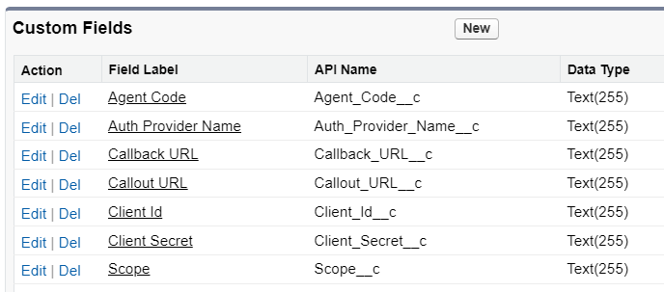
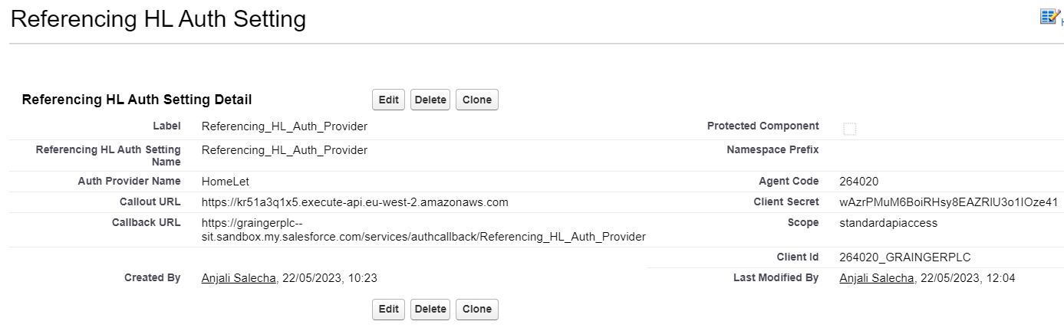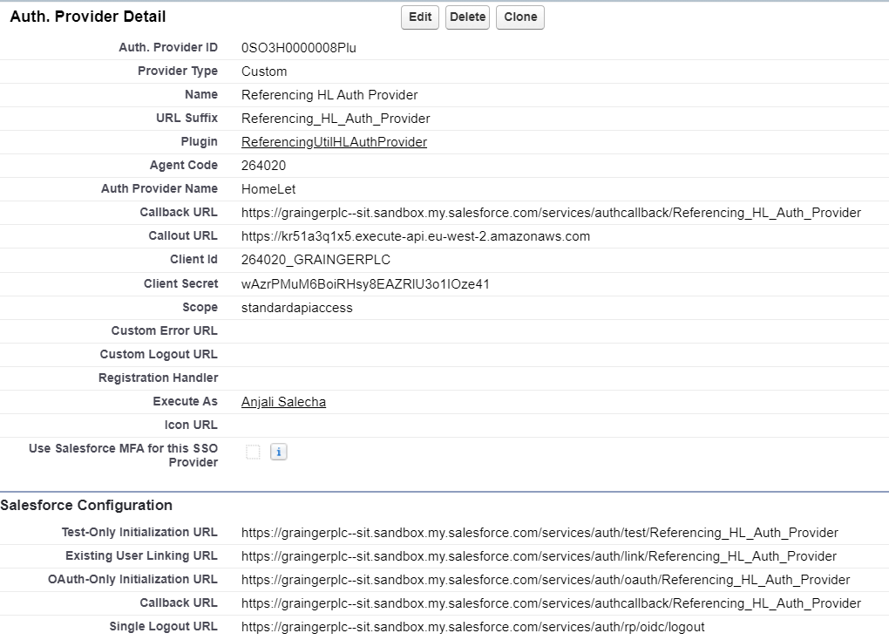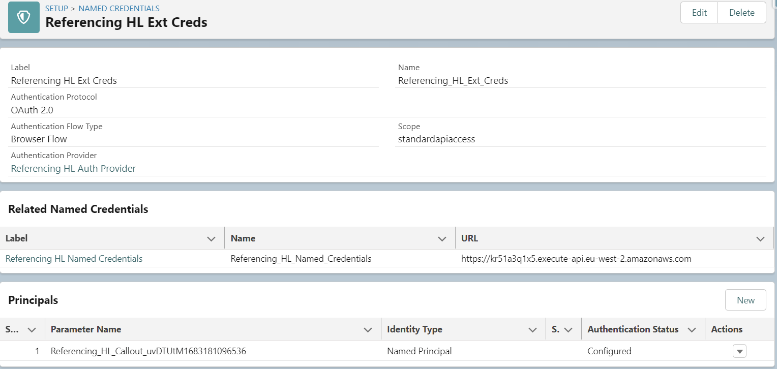

Default Integration Callout Values Configuration
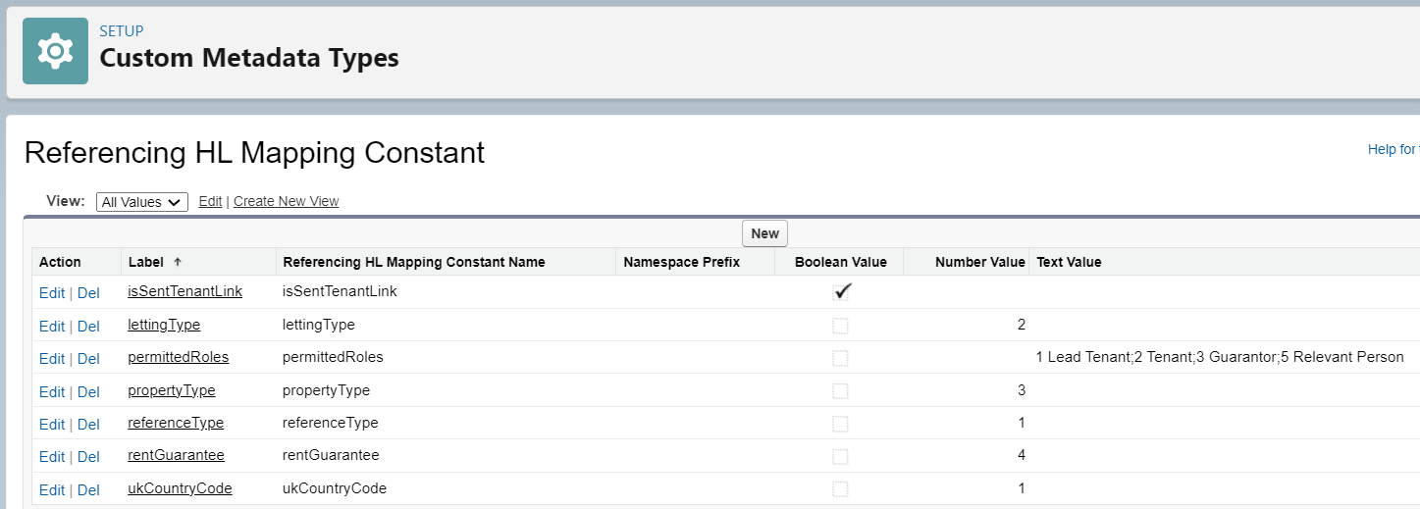

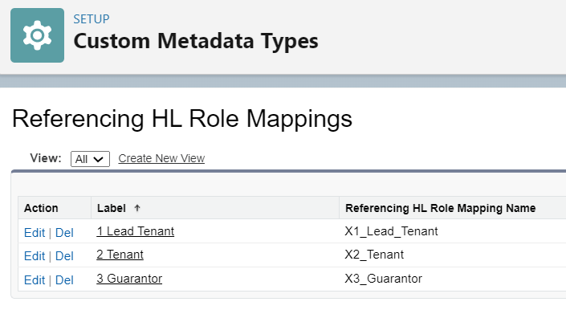
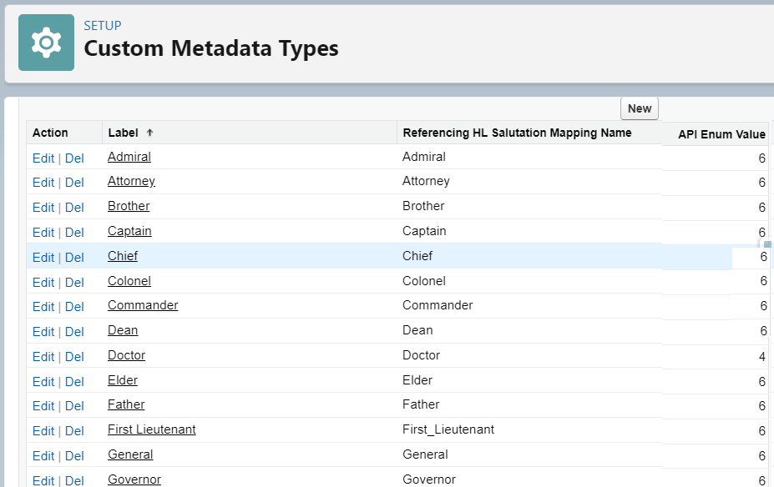

Rest Ordering Data Flows – Detailed Design

To support both Referencing Providers during transition, following is the setup:
If Opp.Referencing_Provider__c == 'HomeLet'
-> async callout to HomeLet API URL : https://kr51a3q1x5.execute-api.eu-west-2.amazonaws.com/standardapi/
Else if Opp.Referencing_Provider__c == 'RightMove'
-> async callout to Rightmove API url - /reference/cancel-order/{api_order_id}

1A) Order New Reference Flow

New Reference Order callout is made to HomeLet APIs as spefified below.

Criteria ( Process Builder ):
( ( HASCHANGED ( Advance_Payment_Made__c ) ||
( HASCHANGED ( Reference_Order_Cancel__c ) && Reference_Order_Cancel__c = FALSE )
)
&& Opp.Advance_Payment_Made__c == TRUE
&& Opp.Exempt_from_Referencing__c == TRUE

Action ( Process Builder ):
Fire @InvocableMethod newOrder()
-> queueable async callout to /CreateReferenceWithInputFromApplicant

Returns ( Apex )
Opp.Reference_Order_Success_Datetime__c = NOW()
Opp.Referencing_Property_Tenancy_Id__c = payload.propertyTenancyId
OCR.Reference_Order_Success_Datetime__c = NOW()
OCR.Referencing_Applicant_Id__c = applicants[n].applicantID
OCR.Referencing_Applicant_Secret_Key__c = applicants[n].applicantID

Payload : include all OpportunityContactRoles related to Opportunity, where OCR Active__c ==
TRUE && Role IN ( ‘Lead-Tenant’ OR ‘Tenant’ OR ‘Guarantor’ )

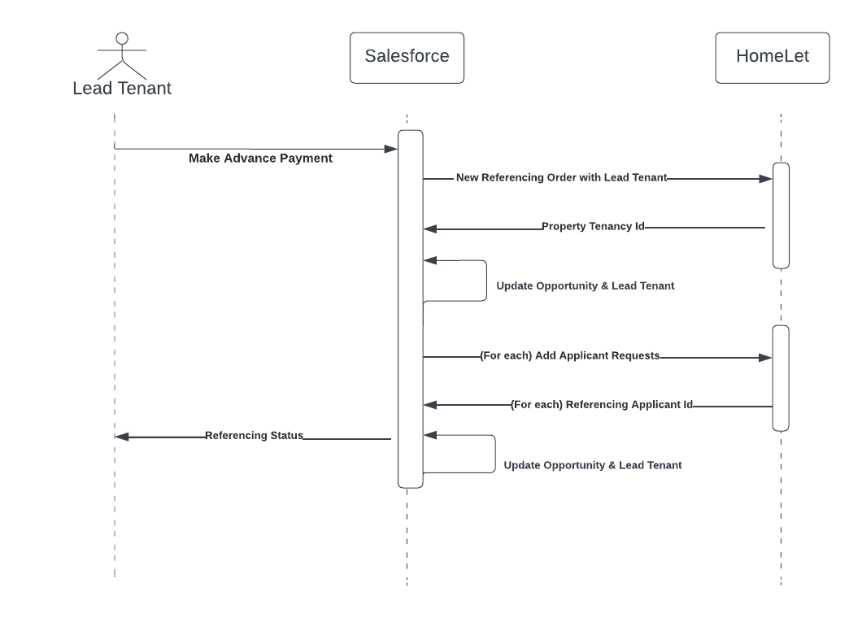

1B) Cancel an order flow
Cancel an order (from a Salesforce Opportunity) by sending a cancellation request from the
Opportunity level by marking it as 'Closed Lost'

Criteria ( Process Builder ):
Opp.Reference_Order_Success_Datetime__c == NOT BLANK
&&
(Opp.Reference_Order_Cancel__c == TRUE &&
ISCHANGED(Opp.Reference_Order_Cancel__c)

Action ( Process Builder ):
Fire @InvocableMethod cancelOrder()
If Opp.Referencing_Provider__c == 'HomeLet'
-> async callout to /CancelTenancy

Returns ( Apex )
Opp.Reference_Order_Cancel_Datetime__c = NOW()
(for each)OCR.Reference_Order_Cancel_Datetime__c = NOW()

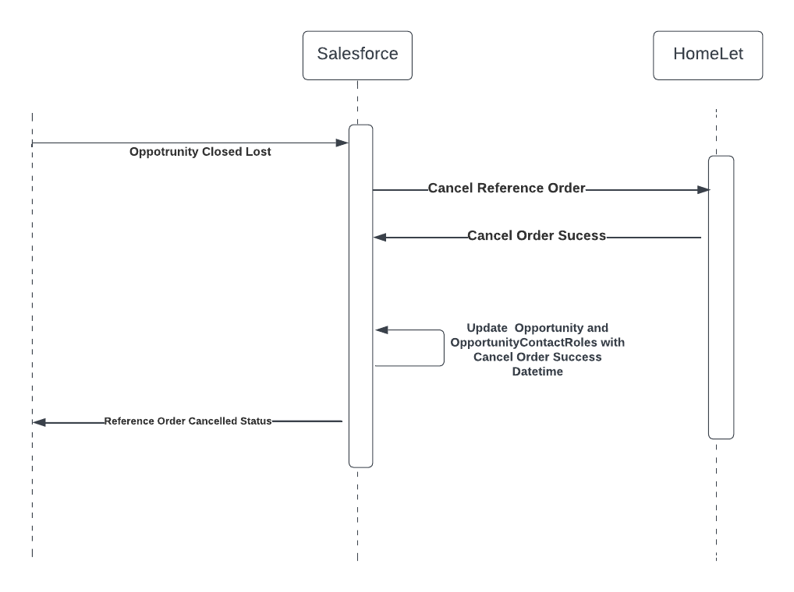

1C) Add Applicants to an existing order flow
Add Applicants to an existing order (from a Salesforce Opportunity Contact Role level) if there is
a currently active order.

Criteria ( Process Builder ):
AND(
NOT([OpportunityContactRole].Exempt_Referencing__c),
[OpportunityContactRole].Active__c,
NOT([OpportunityContactRole].Opportunity.Reference_Order_Cancel__c),
OR(
ISNEW(),
ISCHANGED([OpportunityContactRole].Active__c),
ISCHANGED([OpportunityContactRole].Role)
),
AND(
ISBLANK([OpportunityContactRole].Reference_Order_Success_Datetime__c),
NOT(ISBLANK([OpportunityContactRole].Opportunity.Reference_Order_Success_Datetime__c))
)
)

Action ( Process Builder ):
Fire @InvocableMethod addApplicants()
-> async callout to /AddApplicantToTenancy

Returns ( Apex )
opp.Reference_Order_Success_Datetime__c = NOW()
OCR.Reference_Order_Success_Datetime__c = NOW()
OCR.Referencing_Applicant_Id__c = payload.ReferencingApplicantList.applicantID

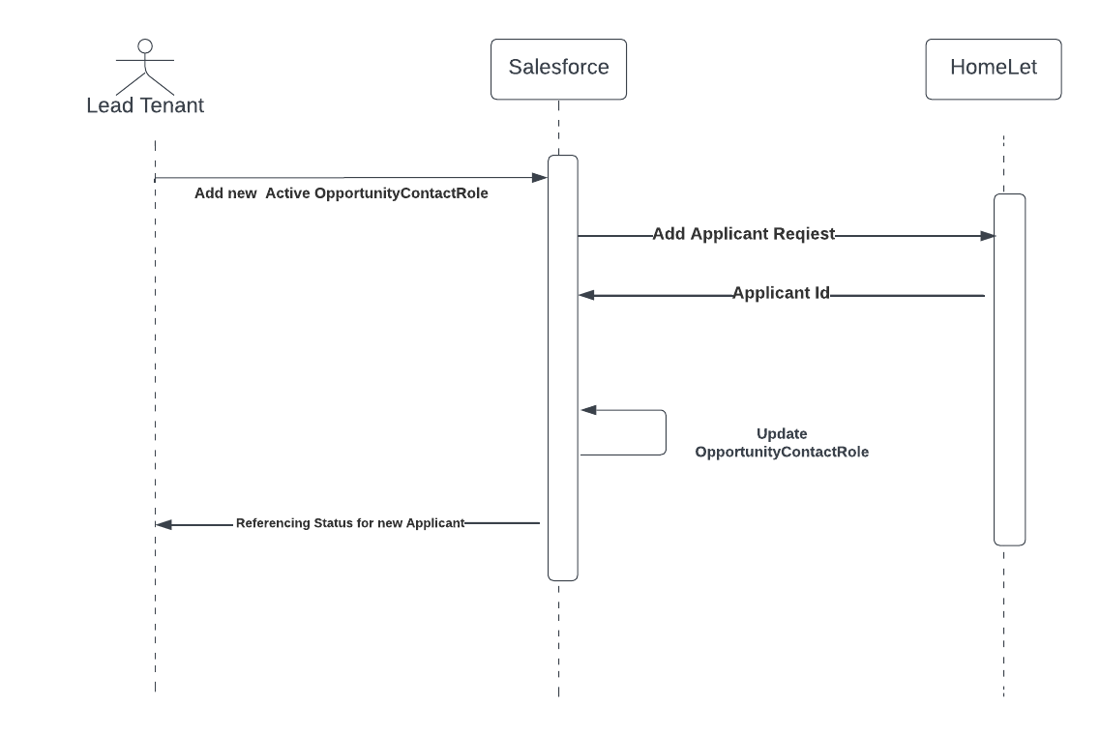

D) Cancel specific applicant on an existing order flow
Cancel one specific applicant on an existing order (from a Salesforce Opportunity Contact Role
level) if there is a currently active order.

Criteria ( Process Builder ):
AND(
NOT(ISBLANK([OpportunityContactRole].Reference_Order_Success_Datetime__c)),
ISBLANK([OpportunityContactRole].Reference_Order_Cancel_Datetime__c ),
NOT(ISPICKVAL([OpportunityContactRole].Reference_Check_Status__c,"Completed")),
OR(
AND(
[OpportunityContactRole].Active__c = false,
ISCHANGED([OpportunityContactRole].Active__c)
),
AND(
ISPICKVAL([OpportunityContactRole].Role, '4 Permitted Occupier'),
ISCHANGED([OpportunityContactRole].Role)
),
AND(
[OpportunityContactRole].Exempt_Referencing__c = true,
ISCHANGED( [OpportunityContactRole].Exempt_Referencing__c)
)
)
)

Action ( Process Builder ):
Fire @InvocableMethod cancelApplicant()
-> async callout to /CancelApplicantFromTenancy

Returns ( Apex )
OCR.Reference_Order_Cancel_Datetime__c = NOW()
OCR.Reference_Order_Success_Datetime = BLANK

Connecting and Updating Salesforce Referencing Status

Salesforce Composite REST APIs can be used to make updates on SF Referencing requests. More details here:
https://developer.salesforce.com/docs/atlas.en-us.api_rest.meta/api_rest/resources_composite_composite.htm

Salesforce Dev sandbox connection details are as follows:
consumer key
3MVG9buXpECUESHhbADaNAlVSkC1HddQxQS119X0hw2zaw_RMWZjsw0DJ757TkLPB7YrX43Ah9UdEeqc4cOEr

secret
41987B750F6E6B9962A8B4A780E9E33F76E9EA226A0981D17197D46919248B42

Example request as shown in screenshot.

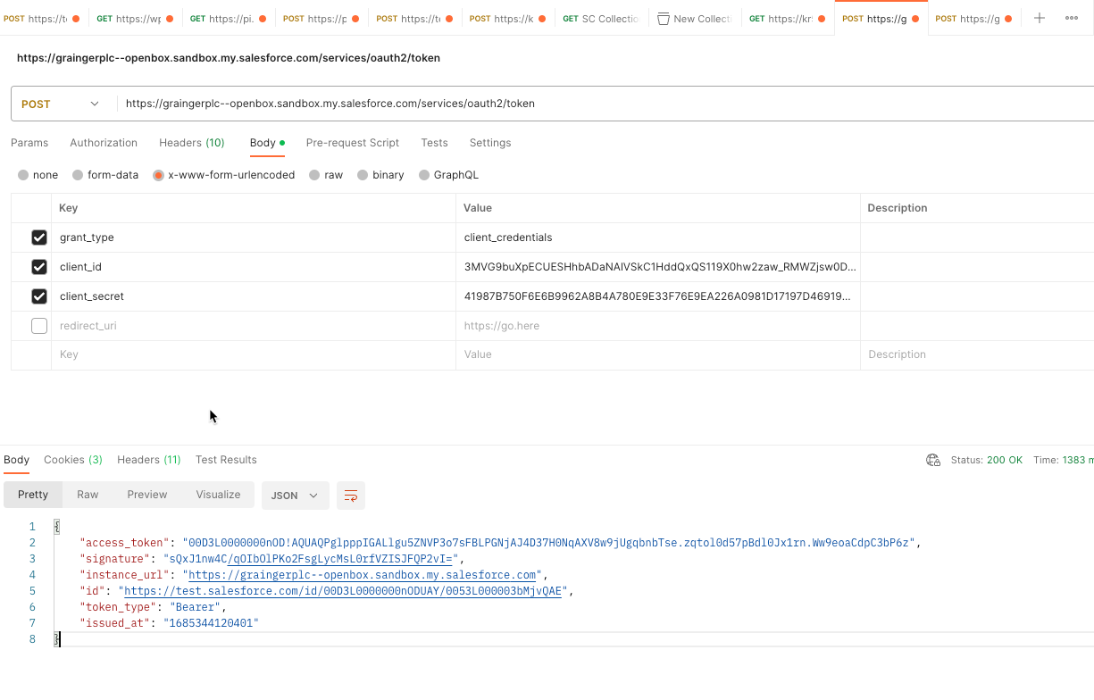
List of fields to be updated on Salesforce upon referencing request completion:
OCR. Reference_Check_Status__c
OCR.Referencing_Outcome__c
Contact. MailingCity
Contact. MailingCountry
Contact. MailingPostalCode
Contact. MailingState
Contact. MailingStreet

Field Mapping Doc
https://openboxsoftwareweb.sharepoint.com/:x:/r/sites/GraingerPLC/_layouts/15/Doc.aspx?sourcedoc=%7B4373F971-BD59-4B72-91AB-03F17BEB1AF4%7D&file=SF%20Field%20Mappings%20V1.xlsx&action=default&mobileredirect=true

JIRA Epic
https://graingerplc.atlassian.net/browse/CI-11990

Vision + API Documentation
https://openboxsoftwareweb.sharepoint.com/sites/GraingerPLC/Project%20Documents/Forms/AllItems.aspx?ct=1682499545125&or=Teams%2DHL&ga=1&id=%2Fsites%2FGraingerPLC%2FProject%20Documents%2FHomeLet%20Integration%2FReceived%20from%20client%2FVision%2B%20API%20Documentation%20V%20r1%2E0%2Epdf&viewid=abbd596a%2D4686%2D4960%2D8bca%2D84e0f3137926&parent=%2Fsites%2FGraingerPLC%2FProject%20Documents%2FHomeLet%20Integration%2FReceived%20from%20client

Van Mildert Integration Specification
https://openboxsoftwareweb.sharepoint.com/sites/GraingerPLC/Project%20Documents/Forms/AllItems.aspx?ct=1682499545125&or=Teams%2DHL&ga=1&id=%2Fsites%2FGraingerPLC%2FProject%20Documents%2FHomeLet%20Integration%2FReceived%20from%20client%2FVan%20Mildert%20Integration%20Specification%2Epdf&viewid=abbd596a%2D4686%2D4960%2D8bca%2D84e0f3137926&parent=%2Fsites%2FGraingerPLC%2FProject%20Documents%2FHomeLet%20Integration%2FReceived%20from%20client

